1-(A) Payload for windows .

1-(B)(C)

Transfer the payload to the victims machine and exploit the victims machine . 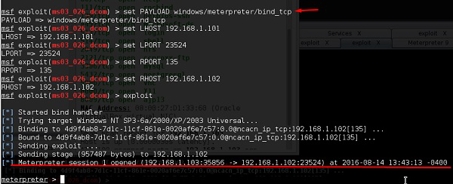

2-(A) Creat an FTP server.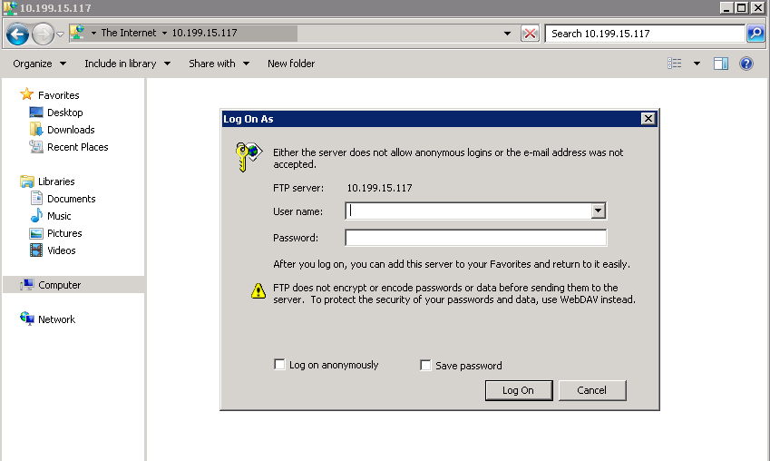

2-(B) Access the FTP server from windows command prompt.